Conditional Ecological Legitimacy: Qur’anic Environmental Ethics and Religious Organizations in Indonesia’s Mining Governance
Abdul Basid
Arabic Language Department, Faculty of Letters, Universitas Negeri Malang, Indonesia
Corresponding author: abdul.basid.fs@um.ac.id
Abstract
Indonesia’s policy of prioritizing mining business permits for religious mass organizations raises a central ethical question: can institutions grounded in moral authority enter extractive governance without eroding their ecological credibility? This study develops an operational Qur’anic framework for evaluating such participation, focusing on QS Al-Baqarah 2:205 and related principles of amanah, mīzān, prevention of fasād, harm prevention, ecological justice, and public accountability. Using contextual Qur’anic interpretation, directed content analysis, and critical synthesis of the supplied literature and public-comment excerpts, the article translates Islamic environmental ethics into institutional tests. The findings show that legitimacy cannot be inferred from religious identity, legal eligibility, or welfare claims. It must be demonstrated through ecological thresholds, community participation, ownership disclosure, independent monitoring, rehabilitation finance, and credible exit duties. The article advances a conditional, evidence-based, continuously evaluated, and revocable model of ecological legitimacy for religious participation in Indonesia’s mining governance.
Keywords | Islamic environmental ethics; religious organizations; mining governance; ecological legitimacy; Indonesia
مستخلص البحث
تتناول هذه الدراسة سؤالاً أخلاقياً محورياً نشأ بعد منح أولوية الوصول إلى تراخيص التعدين للمنظمات الدينية في إندونيسيا هل تستطيع المؤسسات ذات السلطة الأخلاقية المشاركة في الحوكمة الاستخراجية دون إضعاف مصداقيتها البيئية؟ تطور الدراسة إطاراً قرآنياً عملياً يستند إلى الآية 205 من سورة البقرة، ويرتبط بمفاهيم الأمانة والميزان ومنع الفساد ودفع الضرر والعدالة البيئية والمساءلة العامة. وباستخدام تفسير سياقي وتحليل محتوى موجّه ومراجعة نقدية للأدبيات، تترجم الدراسة الأخلاقيات البيئية الإسلامية إلى اختبارات مؤسسية قابلة للتحقق. وتخلص إلى أن الشرعية البيئية لا تُستمد من الهوية الدينية أو الأهلية القانونية أو دعاوى الرفاه، بل من أدلة مستقلة حول الحدود البيئية ومشاركة المجتمع والشفافية والرصد المستقل والتمويل الكافي لإعادة التأهيل والقدرة على الانسحاب عند بقاء ضرر غير مقبول.
كلمات أساسية | الأخلاقيات البيئية الإسلامية؛ المنظمات الدينية؛ حوكمة التعدين؛ الشرعية البيئية؛ إندونيسيا
1. Introduction
Indonesia’s decision to prioritize access to special mining business permit areas for religious mass organizations has shifted environmental governance into a domain typically associated with moral authority, social welfare, education, and religious service. The controversy is not simply whether a legally eligible organization may participate in mining. It concerns whether an institution whose public legitimacy rests in part on claims of ethical guidance can enter a sector associated with land disturbance, water stress, biodiversity pressures, livelihood disruption, and long-term closure obligations without creating a contradiction between mission and practice. Extractive development reshapes territory, authority, and access to natural resources, while its benefits and burdens are commonly distributed across different populations and time horizons (Bebbington et al., 2008; Lèbre et al., 2020; Sonter et al., 2020). The question is especially consequential for major Muslim organizations because their decisions are judged not only through administrative law and economic policy, but also through expectations of religious consistency.
The Indonesian policy debate is structured by competing narratives. Regulatory and legal studies describe the prioritization of mining areas for religious business entities as an instrument of economic participation and welfare distribution, yet they also distinguish administrative eligibility from technical capability, public-interest protection, and environmental responsibility (Apriyanto & Maruf, 2024; Prastika et al., 2024). Human rights analysis highlights concerns regarding land, health, participation, livelihoods, and safe environments around concessions (Putera, 2024). More recent studies identify additional risks related to ecological justice, corporate opacity, political accommodation, and shifts in institutional reasoning when religious organizations become direct beneficiaries of extractive policies (Alamri et al., 2025; Miliasari et al., 2025; Rusdiana et al., 2025; Yunus et al., 2025). These concerns are not merely external criticism. Research on Muhammadiyah, Nahdlatul Ulama, and local anti-mining mobilization shows that religious organizations can simultaneously act as environmental advocates, political intermediaries, community representatives, and economic participants, thereby generating difficult questions about independence and accountability (Alkatiri & Kiwang, 2023; Setiawan et al., 2022; Wahdini & Jubba, 2024).
The ecological dimension becomes sharper when the policy is read through the Qur’anic vocabulary of human responsibility. Islamic environmental ethics does not treat nature as an ownerless inventory whose value is exhausted through profitable use. Divine ownership limits human claims, while khilāfah and amanah place resource use within a relationship of delegated responsibility, restraint, justice, and accountability (Izzi Dien, 2000; Foltz et al., 2003; Baharuddin & Musa, 2017). Muslim environmentalism is also institutionally diverse: scripture, jurisprudence, education, activism, and organizational practice may reinforce one another, but religious language does not automatically produce ecological action (Gade, 2019, 2023; Jenkins et al., 2018; Koehrsen, 2021). Contemporary Qur’anic environmental scholarship similarly stresses stewardship, balance, biodiversity, conservation, and prevention of corruption, while warning that normative teaching must be converted into institutional practice (Abdelzaher et al., 2019; Aboul-Enein, 2018; Bakar et al., 2025; Nur et al., 2025).
QS Al-Baqarah 2:205 is particularly relevant because it connects moral inconsistency with material destruction. The verse describes an actor whose persuasive presentation is followed by conduct that spreads fasād and destroys al-ḥarth and al-nasl. Classical exegetes differ in emphasis, but they consistently connect the verse with tangible injury to cultivation, living beings, livelihood, and collective continuity (Al-Ṭabarī, n.d.; Ibn Kathīr, n.d.; Al-Qurṭubī, n.d.; Ibn ʿĀshūr, n.d.). A contextual interpretation may therefore examine how the verse’s moral direction bears on contemporary institutional conduct without claiming that modern mining is the verse’s exclusive historical referent (Saeed, 2006). In this article, al-ḥarth and al-nasl are treated as ethically generative categories encompassing productive ecosystems, food and water security, community reproduction, public health, and intergenerational continuity.
Despite this relevance, the literature remains fragmented. Islamic environmental scholarship often establishes why stewardship, balance, and restraint matter, but less often specifies how those values should alter contracts, monitoring systems, financial liabilities, decision rights, or exit rules. Conversely, extractive-governance scholarship develops concepts such as social license, due diligence, community participation, and operational risk without systematically engaging Qur’anic moral reasoning (Franks et al., 2014; Owen & Kemp, 2013; Prno & Slocombe, 2012). Indonesian studies illuminate regulation, media controversy, and institutional positioning, yet an integrated framework connecting QS Al-Baqarah 2:205 to verifiable governance requirements remains underdeveloped (Rohma, 2024; Romadlan et al., 2025). The central gap is therefore not the absence of environmental values, but the absence of a disciplined translation from value to institution.
A further conceptual problem concerns the difference between legal authority, social acceptance, and ecological legitimacy. Mining research shows that a permit does not create enduring social license; legitimacy is generated through trust, procedural fairness, recognition, responsiveness, and continuing performance (Kemp et al., 2011; Owen & Kemp, 2013; Prno & Slocombe, 2012). Religious organizations add another layer because their authority is partly normative. Their legitimacy can be damaged not only by unlawful conduct but also by lawful conduct that contradicts their public ethical commitments. The framework developed here therefore treats law as a necessary floor, social license as a relational process, and Qur’anic ecological legitimacy as a higher, outcome-sensitive standard.
This study addresses that gap by treating QS Al-Baqarah 2:205 as the center of an operational environmental-ethics framework. The verse is interpreted in relation to amanah, mīzān, khalīfah, maṣlaḥah, harm prevention, ecological justice, and public accountability. The framework is applied to a bounded primary corpus retained from the manuscript draft: four Qur’anic passages, twelve unique references used in the original descriptive coding, and three quoted public comments. A wider body of literature supplied in References_Summary is used to deepen interpretation and triangulate the framework, but it is not retrospectively added to the denominators reported for the bounded corpus. The study therefore separates the data being described from the scholarship used to interpret those data.
Three research questions guide the analysis. First, what institutional environmental principles can be derived from QS Al-Baqarah 2:205 when it is read contextually alongside amanah, mīzān, and the prevention of harm? Second, how do those principles clarify the distinctive obligations of religious organizations entering mining governance? Third, what do the bounded literature distribution and public-comment excerpts reveal about the moral structure of the Indonesian debate? These questions support a central proposition: ecological legitimacy is conditional, evidence-based, continuously evaluated, and revocable. Neither a legal permit nor a religious identity can establish it in advance.
The study makes three contributions. Conceptually, it translates Qur’anic environmental values into six institutional tests that can be examined through policies, contracts, ecological thresholds, community procedures, monitoring systems, and financial safeguards. Methodologically, it distinguishes normative interpretation from empirical inference, using percentages only for the purposively bounded corpus and refusing to treat three online comments as representative public opinion. In practice, it proposes a Religious Extractive Accountability Protocol that integrates environmental due diligence, social legitimacy, critical natural capital protection, and faith-based responsibility (Ekins et al., 2003; Extractive Industries Transparency Initiative, 2023; OECD, 2018).
The novelty lies in moving from value enumeration to governance design. Institutions do not act through ethical vocabulary alone; they act through ownership structures, partnership contracts, budgets, incentives, technical standards, disclosure practices, and sanctions. Amanah becomes operational only when responsibility cannot be outsourced. Mīzān becomes operational only when ecological thresholds and no-go conditions are defined. The prohibition of fasād becomes operational only when claims of welfare are tested against effects on life-support systems. This shift responds to the broader challenge identified in Eco-Islam research: advancing from the reasons for environmental care toward the behavioral and organizational mechanisms through which environmental commitments produce outcomes (Abdelzaher et al., 2019).
The framework also clarifies the burden of proof. In conventional project advocacy, critics are often expected to demonstrate that unacceptable harm will occur. A precautionary approach reverses that expectation where risk is serious, cumulative, or potentially irreversible: the actor proposing extraction must provide credible evidence that ecological systems, affected communities, and future generations are protected (United Nations, 1992). Islamic doctrines of maṣlaḥah and the removal of harm reinforce this consequence-oriented approach by refusing to separate the claimed public benefit from the harm generated by the means used to obtain it (Auda, 2008; Gasser, 2019; Kamali, 2008). For religious organizations, this burden is not punitive; it follows from the trust they claim and the authority they exercise.
2. Qur’anic Environmental-Ethics Framework
2.1 Religious Organizations, Moral Authority, and Extractive Governance
Religious organizations occupy a distinctive governance position because they combine moral authority, associational networks, service provision, and political influence. Religion can motivate environmental action through worldviews, education, collective identity, and public narratives, but these effects remain contingent on institutional priorities and capacity (Jenkins et al., 2018; Koehrsen, 2021). In extractive governance, this combination creates both possibility and risk: religious institutions may impose stronger ethical constraints, yet they may also use inherited trust to legitimate commercial arrangements that have not been independently examined. The framework therefore begins with institutional conduct rather than presumed virtue.
2.2 Amanah, Mīzān, and Ecological Order
The first principle is amanah, or trusteeship. Natural resources may be used, but their use takes place under divine ownership and delegated human responsibility. Legal access therefore cannot be equated with unrestricted moral entitlement. Amanah demands responsibility across the full project life cycle, including partner selection, environmental assessment, pollution prevention, emergency response, rehabilitation, and post-closure liabilities (Baharuddin & Musa, 2017; Foltz et al., 2003; Izzi Dien, 2000). For a religious organization, the duty is intensified because failure affects not only environmental performance but also the credibility of the institution’s public moral teaching.
The second principle is mīzān, or balance. Mīzān is not a promise that any economic activity can be balanced by later compensation. It requires attention to ecological relationships, carrying capacity, cumulative effects, hydrological integrity, biodiversity, and thresholds beyond which loss becomes irreversible. This interpretation aligns with strong-sustainability scholarship, which distinguishes substitutable assets from critical natural capital whose functions cannot be safely replaced by financial or manufactured capital (Ekins et al., 2003; Neumayer, 2013). It also accords with the Al-Mizan covenant’s call for faith communities to align governance with balance, justice, mercy, and care for creation (United Nations Environment Program et al., 2024).
2.3 QS Al-Baqarah 2:205 and the Material Test of Fasād
The third principle is the prohibition of fasād fī al-arḍ. In QS Al-Baqarah 2:205, corruption becomes recognizable through effects: cultivation and progeny are destroyed despite an outward presentation associated with benefit or reform. Classical tafsir supports an outcome-oriented reading in which eloquence or professed intention cannot override material consequences (Al-Ṭabarī, n.d.; Ibn Kathīr, n.d.; Al-Qurṭubī, n.d.; Ibn ʿĀshūr, n.d.). In contemporary institutional terms, fasād may arise through deliberate abuse, but also through negligent governance, regulatory capture, concealed ownership, underfunded rehabilitation, or the normalization of foreseeable pollution. Khalid (2019) similarly argues that environmental corruption is embedded in systems of excessive consumption and production, rather than in isolated personal behavior.
2.4 Harm Prevention, Maṣlaḥah, and Precaution
The fourth principle is prevention of harm. Maṣlaḥah is not established merely by naming revenue, employment, or organizational independence as public benefits. A systems-oriented maqāṣid approach evaluates both means and consequences, including effects on life, dignity, wealth, health, and future capability (Auda, 2008; Kamali, 2008). The legal maxim that harm must be removed supplies a basis for preventive intervention where damage is foreseeable (Gasser, 2019), while the precautionary principle rejects delay when threats of serious or irreversible damage exist despite incomplete certainty (United Nations, 1992). Applied to mining, these principles require stop-work authority, suspension thresholds, and an exit option when residual risks remain unacceptable.
2.5 Ecological Justice and Strong Sustainability
The fifth principle is ecological justice. Environmental justice includes distribution, recognition, participation, and the capabilities required for communities to sustain valued lives (Schlosberg, 2007). Mining conflicts show that affected people may resist not only inadequate compensation but also threats to land, culture, water, health, identity, and political autonomy (Temper et al., 2018). Social-impact assessment must therefore examine differentiated effects across gender, livelihood, health, heritage, displacement, and institutional trust throughout the project cycle (Mancini & Sala, 2018). In the Indonesian debate, these concerns are particularly important when national or organizational benefits are spatially separated from the burdens borne by concession-area communities (Miliasari et al., 2025; Putera, 2024).
2.6 Transparency and Non-Delegable Accountability
The sixth principle is transparent accountability. Religious reputation cannot replace evidence. Responsible extractive governance requires disclosure of licenses, contracts, beneficial ownership, revenues, environmental information, risk-management measures, monitoring results, and remediation (Extractive Industries Transparency Initiative, 2023; OECD, 2018). Social license is relational and revocable rather than a public-relations asset; it depends on trust, procedural fairness, continuing acceptance, and credible performance (Owen & Kemp, 2013; Prno & Slocombe, 2012). Transparency is also an anti-corruption safeguard where preferential licensing and opaque partnerships may create conflicts of interest or opportunities for corporate capture (Rusdiana et al., 2025). Together, the six principles form the evaluative structure presented in Figure 1 and operationalized in Table 2.
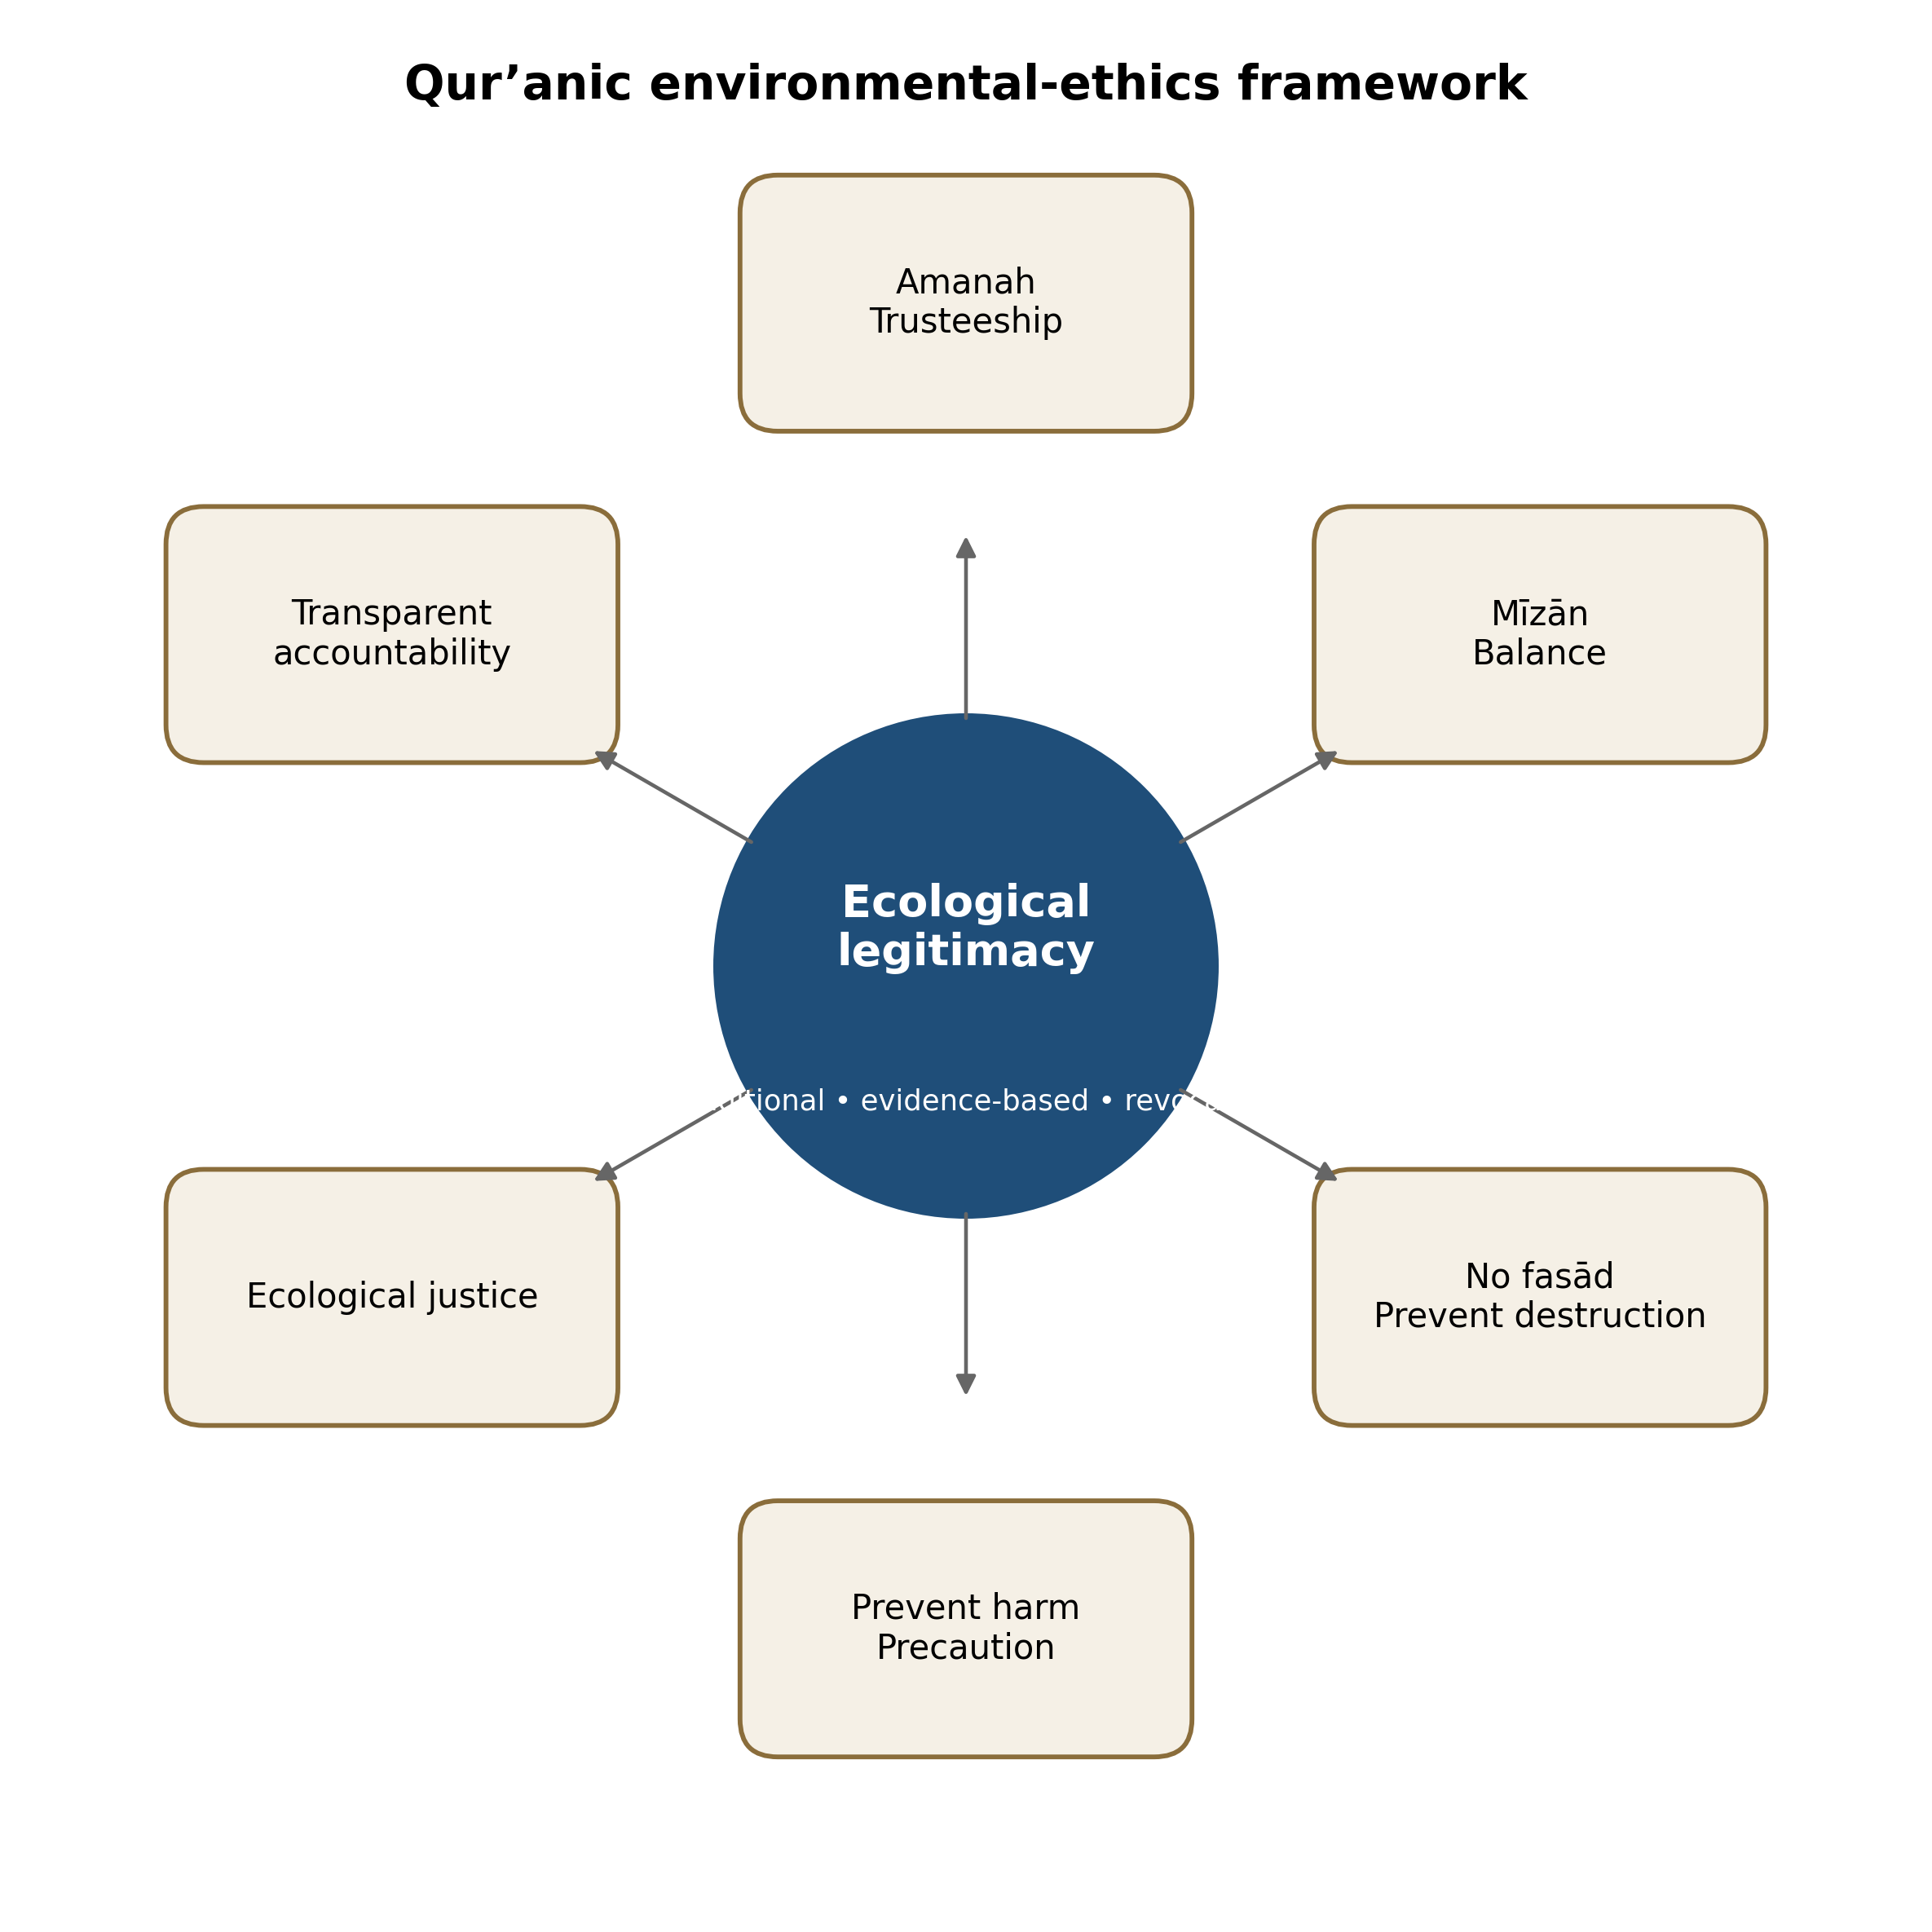
Figure 1. Qur’anic environmental-ethics framework for evaluating the ecological legitimacy of religious participation in mining. The six principles operate jointly; no single principle is sufficient on its own.
3. Materials and Methods
3.1 Research Design
This research used an interpretive qualitative design with a directed content-analysis component. The design was appropriate because the available material consisted of a manuscript draft, Qur’anic and tafsir discussion, a small bibliography used as a primary analytical corpus, and three public-comment excerpts rather than a structured survey or mine-level environmental dataset. Directed content analysis permits theoretically derived concepts to guide coding while preserving transparency about how categories are defined and applied (Hsieh & Shannon, 2005). Thematic analysis supported the identification of patterned meanings, whereas content-analysis principles required explicit units, denominators, and limits on inference (Braun & Clarke, 2006; Krippendorff, 2018).
3.2 Data Sources and Corpus Boundaries
The primary analytical corpus contained four categories of material. First, QS Al-Baqarah 2:205 served as the principal text and was read alongside QS Al-Baqarah 2:30, QS Ar-Rahman 55:7–9, and QS Ar-Rum 30:41 as retained in the draft. Second, the original bibliography was deduplicated from thirteen entries to twelve unique sources. Third, three direct public-comment excerpts preserved in the draft were retained. Fourth, the draft’s interpretive claims concerning religious organizations, mining policy, the green economy, and ecological accountability were examined within the textual corpus. The wider References_Summary document functioned as a secondary interpretive corpus: it strengthened conceptual comparison and methodological justification but was not included in the descriptive frequencies reported for the original bounded materials.
3.3 Coding Strategy
The twelve primary references were coded by dominant thematic orientation using their titles, abstracts where available in the supplied materials, and the role assigned to them in the draft(Basid, 2024; Basid et al., 2025; Basid, Fauzan, et al., 2024; Basid, Kholidah, et al., 2024; Faizin et al., 2025; Hanafi et al., 2024). Four categories were retained: Qur’anic ecology and green economy; mining regulation and permit governance; public discourse, media, and digital activism; and human-rights or social risk. Dominant-orientation coding does not imply that a source addresses only one theme. It provides a reproducible description of a small corpus while avoiding an artificial multiplication of counts. Coding categories were tied directly to the research questions, and numerical claims were restricted to clearly defined units and denominators (Krippendorff, 2018).
The three public comments were coded by orientation. Critical or oppositional comments expressed disappointment, anticipated damage, rejected an organizational decision, or questioned competence. Conditional support expressed trust while attaching explicit expectations of caution, expertise, transparency, or religious consistency. Unconditional support was defined as approval without environmental, technical, moral, or governance conditions. Each excerpt was also interpreted for its principal moral claim, including leadership trust, institutional competence, ecological caution, and consistency between religious identity and economic conduct.
3.4 Descriptive Statistical Treatment
Descriptive treatment was limited to frequencies and percentages. Literature percentages used twelve unique primary sources as the denominator; comment percentages used three excerpts. Such statistics are suitable for describing categorical distributions within a bounded corpus but cannot be generalized to a population when observations are purposively selected and non-random (Field, 2018). No inferential testing was attempted, and the expanded contextual literature was not added to the original counts. This separation prevents false precision and preserves the distinction between evidence used for description and scholarship used for interpretation.
3.5 Interpretive Procedure
Interpretive analysis proceeded through four stages. Stage 1 identified the ethical concepts fasād, al-ḥarth, al-nasl, mīzān, amanah, khalīfah, maṣlaḥah, justice, and harm prevention. Stage 2 translated each concept into institutional questions concerning ecological thresholds, community participation, decision rights, disclosure, restoration, and long-term liability. Stage 3 compared those questions with the regulatory, media, mining-governance, environmental-justice, and religious-organization literature. Stage 4 synthesized the findings into a conditional-legitimacy model and a proposed accountability protocol. Contextual Qur’anic interpretation was used to connect linguistic and ethical direction with a contemporary problem while avoiding the claim that the verse directly names modern mining policy (Saeed, 2006).
3.6 Credibility, Scope, and Research Ethics
Analytical credibility was strengthened through source-bound interpretation, bibliographic deduplication, explicit category definitions, stated denominators, and a clear distinction between primary and contextual corpora. The study does not attribute unverified environmental outcomes to Muhammadiyah, Nahdlatul Ulama, or any particular concession. It evaluates the ethical conditions under which participation could be considered legitimate. This boundary is essential because project-level concession maps, environmental impact measurements, water quality records, biodiversity indicators, financial disclosures, and community surveys were unavailable.
The public comments were treated as illustrative excerpts already reproduced in the manuscript. No usernames or identifying metadata were retained. Because video links, upload dates, sampling procedures, consent arrangements, and the complete comment corpus were unavailable, the excerpts were not presented as a formal netnography or estimate of public opinion. Internet research ethics requires attention to contextual privacy, user expectations, identifiability, and potential harm, even when content is technically public (Franzke et al., 2020). Platform cultures and sampling choices also constrain inferences from digital traces (Pearce et al., 2019).
Figure 2 summarizes the analytical process, beginning with the bounded primary corpus, continuing through deduplication and coding, and ending with the conditional-legitimacy framework. Table 1 specifies the materials, analytical roles, and quantitative treatment. The design intentionally combines normative reasoning with limited descriptive analysis without presenting either as mine-level environmental measurement.
Table 1. Bounded corpus and analytical treatment.
Material | Items retained | Analytical role | Quantitative treatment
Qur’anic passages | 4 passages | Normative and conceptual interpretation | No frequency inference; principles synthesized
Unique bibliographic sources | 12 sources after deduplication | Thematic composition of the literature corpus | Frequency and percentage by dominant theme and year
Public-comment excerpts | 3 quotations | Illustrative orientation and moral-claim coding | Frequency and percentage by orientation
Uploaded source manuscript | 1 document | Research problem, claims, quotations, and reference boundary | Qualitative restructuring and consistency checking

Note. Percentages describe only the supplied, purposively bounded corpus and are not population estimates.
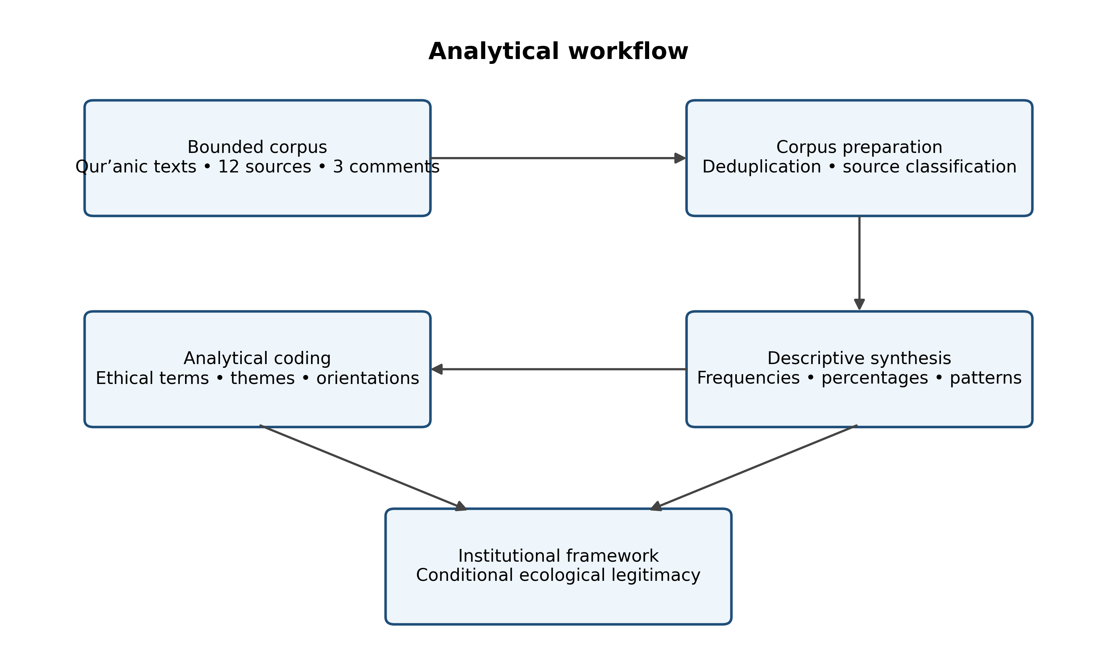
Figure 2. Analytical workflow used to move from the supplied corpus to a conditional institutional-legitimacy framework.
4. Results
The analysis produced five related findings. First, QS Al-Baqarah 2:205 offers an ethical grammar in which public moral claims are tested against material consequences. Second, the primary literature corpus is recent and normatively rich but weak in project-level environmental evidence. Third, the three public-comment excerpts emphasize competence and moral consistency rather than unconditional economic approval. Fourth, the synthesis yields six joint legitimacy tests. Fifth, those tests differentiate accountable stewardship from symbolic responsibility, technocratic extraction, and destructive capture.
4.1 Qur’anic Grammar of Moral Inconsistency
The first finding concerns the structure of QS Al-Baqarah 2:205. The verse places destruction within a sequence: persuasive speech, withdrawal from accountable encounter, striving in the earth, and injury to cultivation and progeny. Classical interpretations associate fasād with observable damage rather than abstract doctrinal error alone (Al-Ṭabarī, n.d.; Ibn Kathīr, n.d.; Al-Qurṭubī, n.d.; Ibn ʿĀshūr, n.d.). The sequence therefore supplies a test of institutional consistency. Claims such as community empowerment, organizational independence, or service to the ummah remain ethically incomplete until they are compared with evidence concerning environmental protection, local participation, public health, and restoration.
The terms al-ḥarth and al-nasl deepen the verse’s environmental significance. Al-ḥarth can encompass cultivation, productive landscapes, food systems, and the regenerative capacity of ecosystems; al-nasl can encompass biological continuity, public health, community survival, and future generations. These categories do not eliminate the need for scientific assessment. Rather, they identify what must be protected. Mining risk extends beyond a pit boundary through roads, waste facilities, water withdrawals, habitat fragmentation, and induced land-use change, while social effects may include health, livelihood, housing, cultural, and governance disruption (Lèbre et al., 2020; Mancini & Sala, 2018; Sonter et al., 2020).
4.2 Literature Composition and the Evidence Gap
The second finding emerges from descriptive coding of the twelve primary references. Six sources (50.0%) primarily address Qur’anic ecology, Islamic green economy, tafsir, or sustainability; three (25.0%) focus on media discourse, public reaction, or digital activism; two (16.7%) primarily examine mining-permit regulation; and one (8.3%) centers on human rights and social risk. Four sources (33.3%) were dated 2024, seven (58.3%) were dated 2025, and one web-based tafsir source (8.3%) was dated 2026. These percentages describe only the original bounded bibliography and do not include the wider contextual literature incorporated during manuscript development.
The distribution reveals a clear evidence asymmetry. The primary corpus is well suited to articulating why ecological responsibility matters, but it cannot establish a concession's environmental performance. The contextual literature reinforces this distinction. Studies of religious-organization mining policy identify legal, ethical, anti-corruption, and institutional tensions, while extractive-governance research shows that environmental and social risk varies by location, commodity, governance quality, and community vulnerability (Alamri et al., 2025; Lèbre et al., 2020; Rusdiana et al., 2025). The result is a strong basis for criteria and burdens of proof, not a factual verdict on a specific project.
4.3 Public-Comment Orientation
The third finding concerns the orientation of the public comments retained in the draft. Two of three excerpts (66.7%) were coded as critical or oppositional, and one (33.3%) as conditional support. None expressed unconditional support. One critical comment expressed disappointment within a religious constituency, indicating a perceived gap between leadership conduct and moral expectations. Another warned that assigning complex responsibilities to actors without appropriate expertise could lead to destruction. The supportive excerpt expressed trust but conditioned that trust on prudence and consistency.
The excerpts cannot establish national public opinion, yet they reveal how the controversy is morally framed in the supplied material. The relevant questions are not limited to whether income will be generated; they concern whether leaders remain trustworthy, whether organizations possess technical capacity, and whether ecological harm will be prevented. This pattern aligns with studies showing that digital activism and online media construct religious mining policy through competing frames of welfare, environmental danger, political accommodation, and reputational consistency (Rohma, 2024; Romadlan et al., 2025).
4.4 Conditional Ecological Legitimacy
The fourth finding is the conditional-legitimacy model. Participation in mining is neither automatically prohibited because the actor is religious nor automatically justified because the stated objective is welfare. It must pass six tests. Amanah asks whether the organization accepts full life-cycle responsibility. Mīzān asks whether carrying capacity, cumulative impacts, and non-substitutable ecological functions are protected. The fasād test asks whether foreseeable damage to ecosystems, livelihoods, and future generations is prevented. Harm prevention asks whether the organization will reject or exit projects with unacceptable residual risk. Ecological justice asks whether affected communities possess substantive influence. Accountability asks whether ownership, performance, finance, and compliance are independently verifiable.
The tests generate observable requirements across the project cycle. Before entry, an organization should publish decision criteria, disclose beneficial ownership and partners, commission an independent environmental and social assessment, identify no-go conditions, establish community participation procedures, and secure rehabilitation financing. During operation, it should release monitoring data, disclose incidents, maintain accessible grievance mechanisms, permit independent audits, and suspend activity when thresholds are exceeded. After closure, it should demonstrate restoration, long-term water management, liability fulfillment, and livelihood transition. These requirements are consistent with international due diligence and extractive transparency standards, while the Qur’anic framework provides their moral rationale (Extractive Industries Transparency Initiative, 2023; OECD, 2018).
The framework clarifies the difference between formal compliance and moral legitimacy. Legal compliance is a minimum condition, not conclusive proof of justice or sustainability. A licensed project may remain ethically deficient where participation is tokenistic, monitoring is inaccessible, rehabilitation finance is inadequate, or harm is displaced to future generations. Social licence similarly depends on continuing trust and fairness and can be withdrawn when performance, leadership, or community expectations change (Owen & Kemp, 2013; Prno & Slocombe, 2012). Transparent refusal to enter a project that fails the tests can therefore constitute institutional success rather than economic failure.
4.5 Governance Positions and Full-Cost Evaluation
The fifth finding is a four-position governance matrix. Accountable stewardship combines comparatively low or effectively controlled ecological risk with high transparency, competence, oversight, and participation. Technocratic extraction combines stronger procedures with high residual risk; it may still fail the mīzān and harm-prevention tests. Symbolic responsibility uses religious and environmental language without sufficient independent verification. Destructive capture combines high ecological risk with low accountability and most closely approximates institutional fasād. The matrix reflects strong sustainability: economic returns cannot automatically substitute for critical natural capital whose loss is irreversible or socially unacceptable (Ekins et al., 2003; Neumayer, 2013).
A related result is that benefit claims require full-cost and distributional analysis. Revenue, employment, organizational funding, and charitable expenditure are visible and often immediate. Water contamination, biodiversity decline, health effects, livelihood displacement, conflict, and post-closure liabilities may emerge slowly or outside the operator’s accounts. Environmental and social conflict can itself generate delays, legal disputes, reputational loss, and project suspension (Franks et al., 2014). Benefits delivered to a national institution therefore cannot be treated as an automatic offset for burdens concentrated in a local community.
The model implies an evidence ladder. At the lowest level are declarations, sermons, and policy statements; these reveal intentions but do not establish performance. The second level comprises governance commitments such as published standards, contracts, and allocated responsibilities. The third level consists of independently verified monitoring, community outcomes, incident records, and financial provisioning. The highest level is demonstrated capacity to correct, restore, suspend, or exit when thresholds are breached. Ecological legitimacy strengthens as evidence moves from assertion toward independently verifiable consequence.
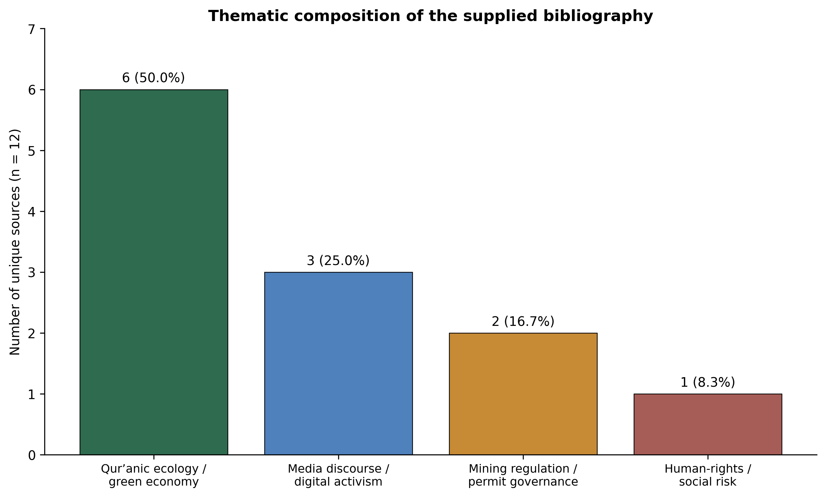
Figure 3. Thematic distribution of the twelve unique sources retained from the supplied bibliography. Classification reflects each source’s dominant orientation as indicated by its title and use in the manuscript.

Table 2. Operational criteria for Qur’anic ecological legitimacy in mining governance.
Principle | Ethical meaning | Institutional test | Indicative evidence
Amanah (trusteeship) | Authority and resources are held as a moral trust. | Does the organization accept full life-cycle responsibility rather than treating the permit as an entitlement? | Public decision criteria; disclosed partners; assigned liabilities; protected whistleblowers.
Mīzān (balance) | Economic use must remain within ecological limits. | Are cumulative impacts, thresholds, and irreversible losses identified before approval? | Independent assessment; carrying-capacity analysis; no-go zones; suspension thresholds.
Prohibition of fasād | Claims of benefit cannot conceal destruction of life-support systems. | Does the project prevent damage to water, land, biodiversity, livelihoods, and future generations? | Open monitoring data; incident disclosure; enforceable corrective action; verified restoration.
Prevention of harm | Avoiding serious damage takes priority over uncertain benefit. | Will the organization reject or exit projects with unacceptable residual risk? | Precautionary decision rule; stop-work authority; termination clauses; emergency finance.
Ecological justice | Benefits and burdens must not be distributed unfairly. | Do affected communities influence decisions and receive protection proportionate to their risk? | Meaningful participation; grievance resolution; livelihood safeguards; fair compensation.
Transparent accountability | Religious reputation cannot replace evidence and scrutiny. | Can outsiders verify ownership, performance, financial flows, and compliance? | Independent audits; public reports; beneficial-ownership disclosure; accessible complaints mechanism.

Note. The indicators are proposed evaluative evidence, not findings about any specific concession or organization.
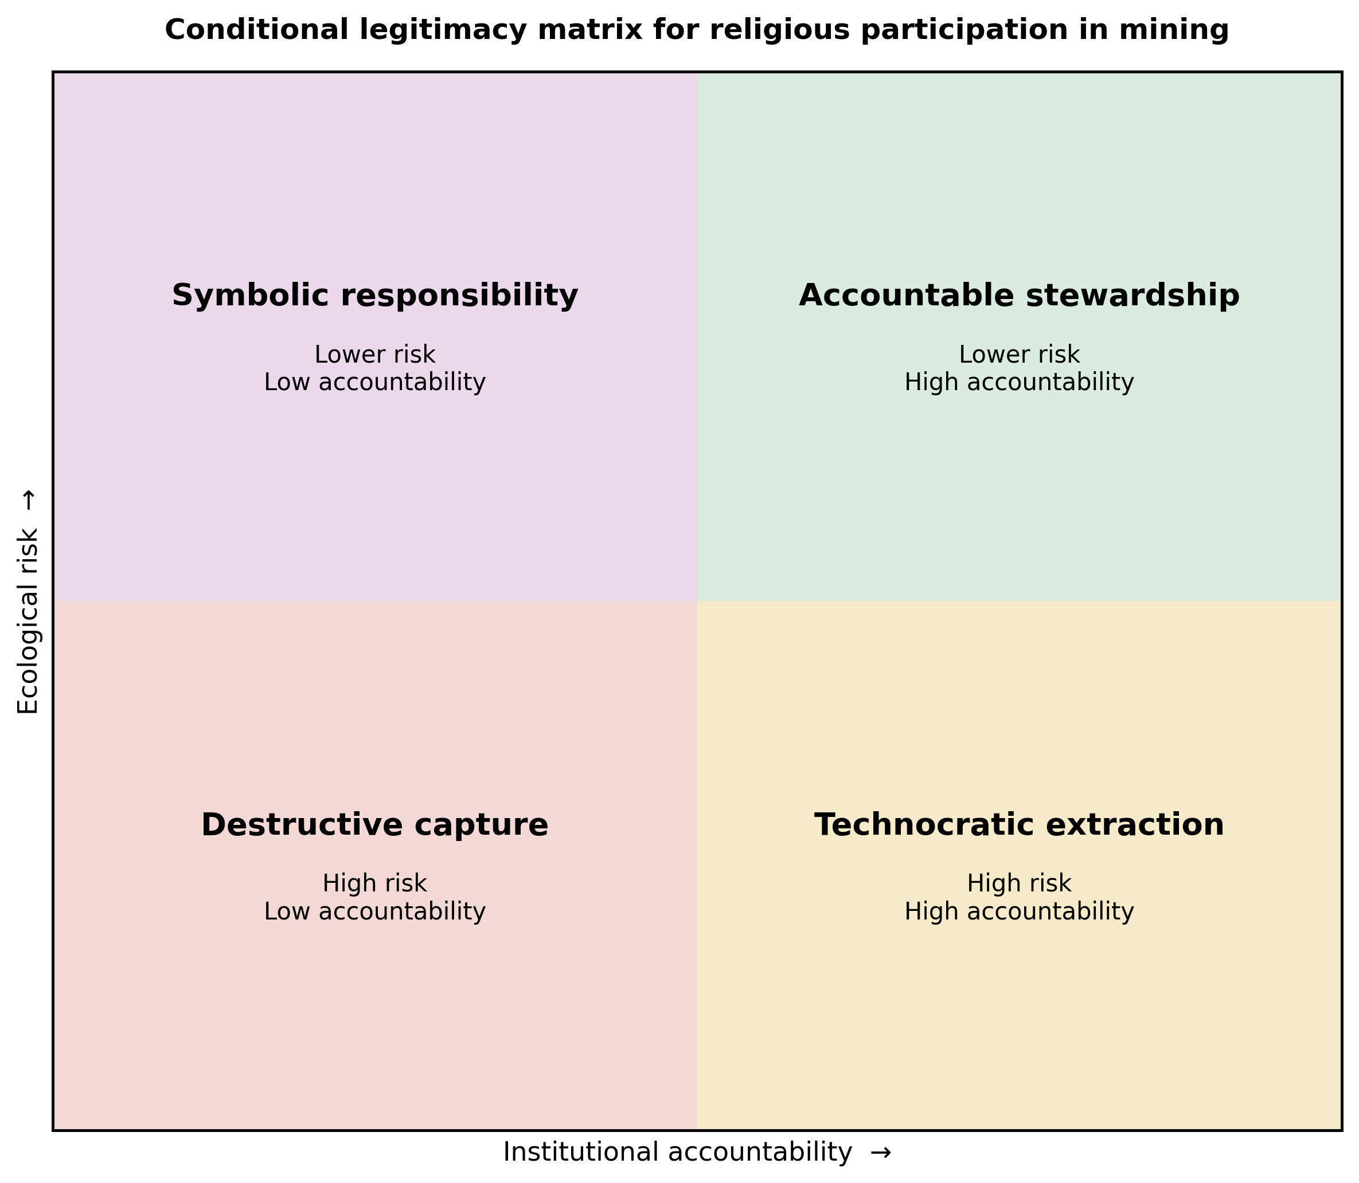
Figure 4. Conditional-legitimacy matrix. High accountability cannot automatically justify irreversible ecological harm, while low accountability substantially weakens any claim of religiously grounded public benefit.
5. Discussion
5.1 Institutional Role Conflict and Moral Authority
The findings position the controversy as an institutional role conflict. Religious organizations hold social capital because they are expected to articulate moral limits, educate communities, provide services, and defend vulnerable groups. Their environmental influence, however, depends on organizational priorities, capacity, political relationships, and whether theology is converted into sustained practice (Jenkins et al., 2018; Koehrsen, 2021). Direct participation in mining may transform religious social capital into economic opportunity, but it may also create financial dependence and reduce critical independence. Indonesian research has already documented tensions among environmental commitments, state intervention, pragmatic legal reasoning, and organizational participation in mining politics (Alamri et al., 2025; Alkatiri & Kiwang, 2023; Wahdini & Jubba, 2024).
5.2 From Religious Language to Material Accountability
QS Al-Baqarah 2:205 makes this role conflict ethically visible by rejecting a separation between moral speech and material consequence. Public claims of welfare must be evaluated by their effects on land, water, health, livelihoods, biodiversity, and future continuity. The verse, therefore, functions as an anti-greenwashing principle: an institution cannot use religious vocabulary, charitable expenditure, or reputational capital to shield extractive practices from scrutiny. This reading converges with critiques of modernity that locate ecological crisis in the reduction of nature to an economic object and with Islamic environmental arguments that call for limits on production, consumption, and institutional power (Khalid, 2019; Nasr, 1996).
5.3 Islamic Green Economy and Strong Sustainability
The framework also refines the idea of an Islamic green economy. Eco-Islam scholarship has argued that the field must move from explaining why Muslims should care toward specifying how beliefs shape behavior, organizational culture, and policy (Abdelzaher et al., 2019). Qur’anic environmental studies provide a rich account of conservation, stewardship, water, biodiversity, moderation, and corruption (Aboul-Enein, 2018; Bakar et al., 2025; Nur et al., 2025). The contribution of the present model is to translate those values into governance: decision criteria, no-go conditions, disclosure duties, performance indicators, restoration finance, and exit obligations. Without such mechanisms, “green,” “Islamic,” or “community-oriented” may remain labels applied to conventional extraction.
Strong sustainability supplies a critical bridge between Qur’anic balance and environmental assessment. A weak approach assumes that ecological losses can be compensated through income, infrastructure, scholarships, employment, or philanthropy. Strong sustainability recognizes that clean water, fertile soil, intact watersheds, biodiversity, cultural landscapes, and intergenerational security may be non-substitutable (Ekins et al., 2003; Neumayer, 2013). This does not imply that every alteration is prohibited. It means that decision makers must identify critical functions and thresholds before comparing them with monetary benefits. The expanding overlap between mining and ecologically significant landscapes makes that requirement increasingly important (Sonter et al., 2020).
5.4 Technical Competence and Non-Delegable Responsibility
The model challenges the assumption that religious identity itself predicts superior mining performance. Religious organizations may possess dense community networks, moral education systems, and long-term social commitments, but they may lack expertise in geology, hydrology, engineering, environmental science, law, and closure management. Regulatory studies of religious mining access repeatedly distinguish welfare objectives from organizational capability and ecological justice (Apriyanto & Maruf, 2024; Miliasari et al., 2025; Prastika et al., 2024). Muhammadiyah’s environmental movement demonstrates that religious institutions can develop ecological expertise and mobilization capacity, yet such capacity must be shown in the specific governance architecture of a mining venture rather than inferred from institutional identity (Setiawan et al., 2022).
Partnership structures are therefore decisive. A religious organization may formally hold rights while operational control is exercised by a commercial partner, contractor, or subsidiary. Moral accountability cannot be outsourced through corporate form. Responsible due diligence requires the organization to identify risks, influence partners, monitor performance, communicate results, and provide remediation when it causes or contributes to harm (OECD, 2018). Contracts should specify environmental thresholds, audit rights, data ownership, beneficial ownership, conflicts of interest, restoration duties, financial guarantees, termination clauses, and liability allocation. Extractive transparency standards reinforce the need for public information on licenses, contracts, revenues, and ownership (Extractive Industries Transparency Initiative, 2023), while the Indonesian corruption-risk literature makes these safeguards especially salient (Rusdiana et al., 2025).
A credible partnership model should also separate oversight from revenue generation. The body responsible for evaluating environmental compliance should not depend financially on production targets, and community grievance channels should not be controlled by the operational partner being challenged. Independent scientific panels, publicly disclosed audit mandates, and protected reporting mechanisms can reduce conflicts of interest. Where an organization lacks the competence or bargaining power to impose these conditions, the ethical response is capacity building or non-entry—not reliance on the operator’s assurances.
5.5 Community Participation and Ecological Justice
Community participation is another non-negotiable condition. Mining benefits and burdens are geographically unequal: national organizations or central leadership may receive income, while nearby communities experience pollution, land loss, health risks, cultural disruption, or changes in livelihoods. Environmental justice requires distribution, recognition, participation, and capability, not compensation alone (Schlosberg, 2007). Just company-community relations must recognize identity, historical experience, unequal power, and locally defined fairness (Kemp et al., 2011). Participation should begin before decisive commitments and include women, farmers, fishers, customary or Indigenous communities where relevant, and groups whose livelihoods depend on affected ecosystems. Consultation after key decisions have been made cannot establish legitimacy.
5.6 Public Criticism as Accountability
Public criticism should consequently be treated as an accountability mechanism rather than hostility toward religion. Digital platforms can expose perceived inconsistency, circulate environmental frames, and challenge institutional authority, but they also contain sampling biases and platform-specific dynamics (Pearce et al., 2019). In the Indonesian case, digital activism and media discourse show that the religious mining policy is evaluated in terms of environmental risk, political relationships, welfare claims, and organizational reputation (Rohma, 2024; Romadlan et al., 2025). A credible response is disclosure, independent review, and protection of dissent—not an appeal to loyalty that places moral authority beyond examination.
5.7 State Responsibility and Regulatory Design
The state retains primary duties of environmental protection, rights protection, technical qualification, and enforcement. Preferential access for religious organizations cannot substitute for competence requirements, conflict-of-interest controls, environmental assessment, public participation, or rehabilitation finance. The policy’s welfare rationale may be legitimate as an objective, but its implementation must be evaluated through public-interest consequences and Islamic ethical constraints (Apriyanto & Maruf, 2024; Prastika et al., 2024; Yunus et al., 2025). Regulators should therefore assess institutional capacity, ownership transparency, environmental expertise, community safeguards, and long-term liability management rather than treating religious reputation as a risk-control mechanism.
5.8 Religious Extractive Accountability Protocol
The practical synthesis is a Religious Extractive Accountability Protocol with five linked screens. The pre-entry ethical screen identifies critical ecosystems, cumulative impacts, unresolved community opposition, feasibility of closure, and no-go conditions. The governance screen discloses ownership, partners, decision rights, conflicts of interest, and financial beneficiaries. The performance screen establishes measurable environmental and social indicators, independent audits, public reporting, and incident disclosure. The financial screen ring-fences rehabilitation, compensation, emergency response, and post-closure liabilities before extraction begins. The exit screen requires suspension, redesign, or withdrawal when ecological, social, or governance thresholds are breached. These components integrate precaution (United Nations, 1992), responsible due diligence (OECD, 2018), and extractive transparency (Extractive Industries Transparency Initiative, 2023).
The protocol should be published before a final investment decision and converted into binding organizational policy. Each screen requires responsible officers, disclosure deadlines, measurable thresholds, independent verification, and consequences for non-compliance. Annual reporting should distinguish operational data from charitable spending so that social programs do not obscure environmental performance. A public dashboard could report water, land, biodiversity, incidents, complaints, rehabilitation finance, and corrective actions. Such design turns ethical commitments into an auditable management system rather than an aspirational statement.
5.9 Revocable Legitimacy and Exit Duties
Revocable legitimacy is the protocol’s central discipline. A permit is not a permanent ethical endorsement, and initial community support is not irrevocable. Social acceptance can change when environmental performance deteriorates, commitments are violated, leadership changes, or new evidence emerges (Prno & Slocombe, 2012). The organization must therefore maintain a credible capacity to stop operations even when withdrawal reduces revenue. This exit option is the practical test of whether amanah outranks financial dependence. It also reduces conflict costs by creating a formal response before unresolved disputes escalate into legal, reputational, and operational crises (Franks et al., 2014; Owen & Kemp, 2013).
5.10 Alternative Development Pathways
Religious organizations also possess development pathways beyond direct extraction. Muslim environmental practice includes education, conservation, community mobilization, sustainable livelihoods, ethical finance, and public advocacy (Gade, 2019). Renewable energy, restoration enterprises, sustainable agriculture, circular-economy initiatives, healthcare, education, and community finance may advance welfare with lower ecological risk. The availability of alternatives matters because maṣlaḥah concerns not only the objective pursued but also whether less harmful means are realistically available. The Al-Mizan covenant similarly calls faith communities to align economic choices with balance, justice, mercy, and responsibility for creation (United Nations Environment Program et al., 2024).
Comparing mining with alternatives should use consistent criteria: expected welfare benefit, distribution, ecological risk, reversibility, capital requirements, institutional competence, and long-term dependence. An alternative need not be impact-free to be ethically preferable; it must offer a more proportionate relationship between benefit and harm. This comparative obligation prevents mining from being treated as inevitable merely because a permit or commercial partner is available.
The argument should not imply that all mining projects are environmentally identical or that every non-mining activity is benign. Risk varies by commodity, geology, hydrology, biodiversity, technology, scale, governance, conflict exposure, and closure conditions (Lèbre et al., 2020). The framework is conditional precisely because project-specific evidence matters. Higher-risk contexts require stronger justification and safeguards; some projects may remain unacceptable because residual damage cannot be reconciled with ecological limits or fair distribution. High procedural quality cannot convert an irreversible loss of critical natural capital into a morally neutral outcome.
5.11 Future Empirical Research
Future research should apply the framework to specific concessions through mixed methods. Environmental indicators should include water and soil quality, land-cover change, biodiversity, emissions, waste, pollution incidents, and rehabilitation progress. Social indicators should include livelihoods, health, gendered impacts, procedural justice, compensation, cultural heritage, and distribution of benefits. Governance indicators should include beneficial ownership, contract transparency, audit independence, grievance outcomes, environmental disclosure, and rehabilitation financing. The social-impact frameworks reviewed by Mancini and Sala (2018) and the due-diligence cycle proposed by the OECD (2018) provide practical starting points for measurement.
A future digital study should document platforms, channels, videos, dates, search terms, sampling rules, language processing, bot filtering, anonymization, and ethical review. A larger corpus could support intercoder agreement, validated Indonesian-language sentiment analysis, thematic co-occurrence, and comparison across organizational constituencies. Yet automated scale should not be confused with representativeness: online discourse is shaped by access, platform culture, visibility algorithms, and coordinated behavior (Franzke et al., 2020; Pearce et al., 2019).
Further theological research should compare classical and contemporary interpretations of fasād, isrāf, mīzān, khalīfah, amanah, and maṣlaḥah. Contextual interpretation can preserve the linguistic and ethical direction of scripture while addressing new institutional conditions (Saeed, 2006). Comparative work should also examine how Muslim environmental ethics is practiced through rights, justice, and community protection, rather than being evaluated solely by the presence of scriptural vocabulary (Gade, 2023).
5.12 Study Limitations
Several limitations must be emphasized. First, the primary descriptive corpus remains small and purposively bounded. Second, the public-comment sample contains only three excerpts and cannot represent national opinion or organizational constituencies. Third, the study did not independently measure any mine’s environmental, financial, or social performance. Fourth, the wider literature was supplied as bibliographic records and abstracts; it was used only for claims consistent with those summaries. Fifth, the framework is normative and diagnostic and requires empirical application before conclusions can be made about a named project. These limitations require caution but do not invalidate the framework’s function as an evidence map.
5.13 Theoretical and Comparative Implications
The theoretical contribution is to convert Qur’anic environmental ethics into institutional questions that can be investigated empirically. This prevents moral certainty from being presented as an environmental measurement and prevents technical compliance from being treated as moral sufficiency. The framework joins three literatures that often remain separate: Islamic environmental ethics, extractive governance, and environmental justice. Its central claim is neither categorical approval nor categorical prohibition, but a disciplined burden of proof.
The framework has implications for internal religious decision-making. Mining decisions should not be confined to business units or political leadership. They require theologians, environmental scientists, public-health specialists, engineers, legal experts, economists, governance professionals, and representatives of affected communities. Deliberation should occur before commercial commitments, and dissenting assessments should be documented. This plural expertise is consistent with the organizational learning implied by Muhammadiyah’s environmental movement and with recent evidence that institutional legal reasoning can shift under political-economic pressure (Alamri et al., 2025; Setiawan et al., 2022).
Religious education and organizational practice must also be aligned. Qur’anic teaching can support environmental health, conservation, and stewardship, while religious leaders and networks can influence environmental perceptions and collective action (Aboul-Enein, 2018; Jenkins et al., 2018; Koehrsen, 2021). These educational efforts lose credibility when an institution’s own investments are opaque. Conversely, publishing impact data, protecting whistleblowers, funding restoration, and withdrawing from unacceptable projects make ecological ethics visible as governance rather than rhetoric.
Finally, the framework is adaptable beyond Indonesia. Religious institutions in many settings own land, manage investments, operate businesses, deliver public services, or influence natural-resource policy. Comparative research can identify a tradition’s environmental norms, translate them into institutional criteria, map the distribution of benefits and harms, and test public moral claims against measurable outcomes. The Indonesian case is distinctive because large religious organizations occupy unusually influential civic roles, but the broader question—how moral institutions behave when they become economic actors—is globally relevant (Gade, 2019; Jenkins et al., 2018).
6. Conclusion
QS Al-Baqarah 2:205 provides a rigorous ethical lens for evaluating religious organizations’ participation in mining by linking morally attractive claims to material consequences for cultivation, life, and continuity. Read together with amanah, mīzān, maṣlaḥah, harm prevention, ecological justice, and accountability, the verse rejects the assumption that religious identity or a welfare objective is sufficient to legitimize extraction.
The bounded analysis found a primary literature base dominated by Qur’anic ecology and green-economy discussions, accompanied by regulatory, media, digital activism, and human rights perspectives. The three available public comments were predominantly critical and framed the issue in terms of competence, trust, and moral consistency. The wider literature deepened this result by showing that religious authority can support environmental action but can also be constrained by organizational incentives, political relationships, technical limitations, and economic dependence.
The proposed model therefore defines ecological legitimacy as conditional, evidence-based, continuously evaluated, and revocable. A religious organization must demonstrate independent environmental and social assessment, protection of critical natural capital, meaningful community participation, transparent partnerships and financial flows, public monitoring data, secured rehabilitation finance, accessible grievance mechanisms, and a credible willingness to suspend or abandon projects whose residual harms remain unacceptable. Formal compliance is necessary but not sufficient.
The principal new insight is that Qur’anic environmental ethics can operate as an institutional accountability architecture. QS Al-Baqarah 2:205 is not limited to personal piety or abstract condemnation of damage; it tests whether public-benefit narratives correspond with protection of ecosystems, communities, and future generations. The decisive question is therefore not whether mining can generate revenue, but whether religious organizations can prove—through transparent, independent, and project-specific evidence—that ecological trust takes precedence over extractive opportunity.
Acknowledgements
Not applicable.
References

Abdelzaher, D. M., Kotb, A., & Helfaya, A. (2019). Eco-Islam: Beyond the principles of why and what, and into the principles of how. Journal of Business Ethics, 155(3), 623–643. https://doi.org/10.1007/s10551-017-3518-2
Aboul-Enein, B. H. (2018). “The earth is your mosque”: Narrative perspectives of environmental health and education in the Holy Quran. Journal of Environmental Studies and Sciences, 8(1), 22–31. https://doi.org/10.1007/s13412-017-0444-7
Alamri, M. S. A., Muslimin, J. M., Mukti, K. W., & Jasin, M. (2025). Text, context and natural conservation: An analysis of Muhammadiyah’s and Nahdlatul Ulama’s Islamic legal thought on fiqh of environment. Nurani, 25(2), 690–715. https://doi.org/10.19109/nurani.v25i2.31305
Alkatiri, F. A., & Kiwang, A. S. (2023). The roles of religious organizations in the decline of the anti-mining movement in Banyuwangi, East Java. Bijdragen tot de Taal-, Land- en Volkenkunde, 179(1), 5–37. https://doi.org/10.1163/22134379-bja10048
Al-Qurṭubī, M. A. A. (n.d.). Al-Jāmiʿ li-aḥkām al-Qurʾān: Tafsīr Sūrat al-Baqarah, verse 205. Tafsir.app. https://tafsir.app/qurtubi/2/205
Al-Ṭabarī, M. J. (n.d.). Jāmiʿ al-bayān: Tafsīr Sūrat al-Baqarah, verse 205. Tafsir.app. https://tafsir.app/tabari/2/205
Apriyanto, D., & Maruf, S. N. A. (2024). Implementasi kesejahteraan masyarakat dalam prioritas WIUPK untuk badan usaha keagamaan berdasarkan PP No. 25 Tahun 2024. Jurnal Hukum dan Kebijakan Publik, 6(3), 367–380.
Auda, J. (2008). Maqasid al-Shariah as philosophy of Islamic law: A systems approach. International Institute of Islamic Thought. https://doi.org/10.2307/j.ctvkc67tg
Basid, A. (2024). From Conflict to Peace: Fuqaha Political Exegesis on Israel’s War Crimes in Palestine. Al-Istinbath: Jurnal Hukum Islam, 9(2), 597–624. Scopus. https://doi.org/10.29240/jhi.v9i2.10597
Basid, A., Fauzan, M., Amrulloh, A., Solichin, M., Nasih, A. M., & Ahmed, B. M. B. (2024). The Role of Nahdlatul Ulama’ (NU) Diplomacy in Promoting Islam Rahmatan Lil ‘Alamin Exegesis to Strengthen Indonesian State-Religion Concepts: A Study of Gus Dur’s Thought. Journal of Islamic Thought and Civilization, 14(2), 224–245. Scopus. https://doi.org/10.32350/jitc.142.14
Basid, A., Kholidah, L. N., Hidayatullah, M. F., Firmansyah, E. K., Zunaih, A. I., & Zahid, R. A. (2024). INTERFAITH MARRIAGE CONTROVERSIES IN SEMARANG: AN ANALYSIS OF QUR’ANIC LEGAL EXEGESIS. Malaysian Journal of Syariah and Law, 12(3), 762–777. Scopus. https://doi.org/10.33102/mjsl.vol12no3.812
Basid, A., Ma’arif, A. S., Junaidi, M. R., Suroiyah, E. N., & Budiya, B. (2025). LEGAL EXEGESIS ON THE EARLY MARRIAGE PHENOMENON AND CERVICAL CANCER IN WOMEN. Petita: Jurnal Kajian Ilmu Hukum Dan Syariah, 10(1), 74–94. Scopus. https://doi.org/10.22373/petita.v10i1.362
Baharuddin, A., & Musa, M. N. (2017). Environmental ethics in Islam. In Islamic bioethics: Current issues and challenges (pp. 161–182). World Scientific. https://doi.org/10.1142/9781783267507_0008
Bakar, S. A., Hussin, H., Rozani, M. A. S., & Ahmad, Z. A. S. (2025). Environmental ethics in the Qur’an: A thematic analysis of conservation and stewardship. Global Journal Al-Thaqafah, 31–45. https://doi.org/10.7187/GJATSI122025-3
Bebbington, A., Hinojosa, L., Bebbington, D. H., Burneo, M. L., & Warnaars, X. (2008). Contention and ambiguity: Mining and the possibilities of development. Development and Change, 39(6), 887–914. https://doi.org/10.1111/j.1467-7660.2008.00517.x
Braun, V., & Clarke, V. (2006). Using thematic analysis in psychology. Qualitative Research in Psychology, 3(2), 77–101. https://doi.org/10.1191/1478088706qp063oa
Ekins, P., Simon, S., Deutsch, L., Folke, C., & De Groot, R. (2003). A framework for the practical application of the concepts of critical natural capital and strong sustainability. Ecological Economics, 44(2–3), 165–185. https://doi.org/10.1016/S0921-8009(02)00272-0
Extractive Industries Transparency Initiative. (2023). EITI standard 2023. https://eiti.org/eiti-standard
Faizin, N., Alfan, M., Basid, A., Ramadhan, M. R., Panatik, S. A., & Kawakip, A. N. (2025). Muslim students’ acceptance of artificial intelligence in Islamic religious education: An extended TAM approach. Discover Education, 4(1). Scopus. https://doi.org/10.1007/s44217-025-00767-1
Field, A. (2018). Discovering statistics using IBM SPSS statistics (5th ed.). SAGE. https://edge.sagepub.com/field5e
Foltz, R. C., Denny, F. M., & Baharuddin, A. (Eds.). (2003). Islam and ecology: A bestowed trust. Harvard University Press. https://hds.harvard.edu/publications/islam-and-ecology-bestowed-trust
Franks, D. M., Davis, R., Bebbington, A. J., Ali, S. H., Kemp, D., & Scurrah, M. (2014). Conflict translates environmental and social risk into business costs. Proceedings of the National Academy of Sciences, 111(21), 7576–7581. https://doi.org/10.1073/pnas.1405135111
Franzke, A. S., Bechmann, A., Zimmer, M., Ess, C. M., & the Association of Internet Researchers. (2020). Internet research: Ethical guidelines 3.0. Association of Internet Researchers. https://doi.org/10.5281/zenodo.4340791
Gade, A. M. (2019). Muslim environmentalisms: Religious and social foundations. Columbia University Press. https://doi.org/10.7312/gade18964
Gade, A. M. (2023). Muslim environmentalisms and environmental ethics: Theory and practice for rights and justice. The Muslim World, 113(3), 242–259. https://doi.org/10.1111/muwo.12474
Gasser, H. (2019). The principle of “no harm” in Islamic law and its application to environmental protection. Arab Law Quarterly, 33(4), 357–380. https://brill.com/display/title/39466
Hanafi, Y., Saefi, M., Ikhsan, M. A., Nur Diyana, T., Faizin, N., Basid, A., & Ramadhan, M. R. (2024). Experiencing less apprehension and engaging religious communication: The team-based project learning practices. Cogent Education, 11(1). Scopus. https://doi.org/10.1080/2331186X.2024.2332852
Hsieh, H.-F., & Shannon, S. E. (2005). Three approaches to qualitative content analysis. Qualitative Health Research, 15(9), 1277–1288. https://doi.org/10.1177/1049732305276687
Ibn ʿĀshūr, M. al-Ṭ. (n.d.). Al-Taḥrīr wa-al-tanwīr: Tafsīr Sūrat al-Baqarah, verse 205. Tafsir.app. https://tafsir.app/ibn-aashoor/2/205
Ibn Kathīr, I. U. (n.d.). Tafsīr al-Qurʾān al-ʿaẓīm: Tafsīr Sūrat al-Baqarah, verse 205. Tafsir.app. https://tafsir.app/ibn-katheer/2/205
Izzi Dien, M. (2000). The environmental dimensions of Islam. Lutterworth Press. https://www.lutterworth.com/product/environmental-dimensions-of-islam-the/
Jenkins, W., Berry, E., & Kreider, L. B. (2018). Religion and climate change. Annual Review of Environment and Resources, 43, 85–108. https://doi.org/10.1146/annurev-environ-102017-025855
Kamali, M. H. (2008). Maqasid al-Shariah made simple. International Institute of Islamic Thought. https://doi.org/10.2307/j.ctvkc67vz
Kemp, D., Owen, J. R., Gotzmann, N., & Bond, C. J. (2011). Just relations and company–community conflict in mining. Journal of Business Ethics, 101(S1), 93–109. https://doi.org/10.1007/s10551-010-0711-y
Khalid, F. (2019). Signs on the Earth: Islam, modernity and the climate crisis. Kube Publishing. https://www.kubepublishing.com/products/signs-on-the-earth-2
Koehrsen, J. (2021). Muslims and climate change: How Islam, Muslim organizations, and religious leaders influence climate change perceptions and mitigation activities. WIREs Climate Change, 12(3), e702. https://doi.org/10.1002/wcc.702
Krippendorff, K. (2018). Content analysis: An introduction to its methodology (4th ed.). SAGE. https://doi.org/10.4135/9781071878781
Lèbre, É., Stringer, M., Svobodova, K., Owen, J. R., Kemp, D., Côte, C., Arratia-Solar, A., & Valenta, R. K. (2020). The social and environmental complexities of extracting energy transition metals. Nature Communications, 11, Article 4823. https://doi.org/10.1038/s41467-020-18661-9
Mancini, L., & Sala, S. (2018). Social impact assessment in the mining sector: Review and comparison of indicator frameworks. Resources Policy, 57, 98–111. https://doi.org/10.1016/j.resourpol.2018.02.002
Miliasari, P. S., Adnan, M., & Abdulrahman, W. (2025). Challenges for religious organizations in realizing ecological justice in the midst of mining legalization in Indonesia. IOP Conference Series: Earth and Environmental Science, 1537(1), 012060. https://doi.org/10.1088/1755-1315/1537/1/012060
Nasr, S. H. (1996). Religion and the order of nature. Oxford University Press. https://academic.oup.com/book/27243
Neumayer, E. (2013). Weak versus strong sustainability: Exploring the limits of two opposing paradigms (4th ed.). Edward Elgar. https://doi.org/10.4337/9781781007082
Nur, A., Husin, H. B., & Yasir, M. (2025). Qur’anic ecotheology and the ethics of forest protection in Indonesia. Jurnal Studi Ilmu-Ilmu al-Qur’an dan Hadis, 26(2), 351–382. https://doi.org/10.14421/qh.v26i2.6312
OECD. (2018). OECD due diligence guidance for responsible business conduct. OECD Publishing. https://doi.org/10.1787/15f5f4b3-en
Owen, J. R., & Kemp, D. (2013). Social licence and mining: A critical perspective. Resources Policy, 38(1), 29–35. https://doi.org/10.1016/j.resourpol.2012.06.016
Pearce, W., Niederer, S., Özkula, S. M., & Sánchez Querubín, N. (2019). The social media life of climate change: Platforms, publics, and future imaginaries. WIREs Climate Change, 10(2), e569. https://doi.org/10.1002/wcc.569
Prastika, A., Putri, M. F. I., & Tasya, V. N. (2024). Urgensi pemberian izin pengelolaan tambang bagi organisasi kemasyarakatan keagamaan di Indonesia: Analisis regulasi dalam PP Nomor 25 Tahun 2024. TARUNALAW: Journal of Law and Syariah, 2(2), 214–224. https://doi.org/10.54298/tarunalaw.v2i02.216
Prno, J., & Slocombe, D. S. (2012). Exploring the origins of “social license to operate” in the mining sector: Perspectives from governance and sustainability theories. Resources Policy, 37(3), 346–357. https://doi.org/10.1016/j.resourpol.2012.04.002
Putera, I. R. (2024). Dinamika pemberian izin pertambangan kepada organisasi kemasyarakatan keagamaan dalam sudut pandang potensi pelanggaran HAM. KULTURA: Jurnal Ilmu Sosial dan Humaniora, 2(8), 239–247.
Rohma, M. N. (2024). Navigating digital activism on environmental movement: Mining license grants to religious organizations in Indonesia. Insignia Journal of International Relations, 11(2), 184–205.
Romadlan, S., Maududi, M. M., & Wahdiyati, D. (2025). Diskursus pemberitaan media online mengenai penerimaan izin usaha pertambangan oleh Muhammadiyah dan Nahdlatul Ulama. Communications, 7(2), 171–193. https://doi.org/10.21009/communications.7.2.3
Rusdiana, E., Darnela, L., Jufri, M., Aidonojie, P. A., & Ezzerouali, S. (2025). The potential for corporate corruption in mining licensing policies for religious organizations in Indonesia. Lex Scientia Law Review, 9(2), 1587–1636. https://doi.org/10.15294/lslr.v9i2.21551
Saeed, A. (2006). Interpreting the Qur’an: Towards a contemporary approach. Routledge. https://doi.org/10.4324/9780203016770
Schlosberg, D. (2007). Defining environmental justice: Theories, movements, and nature. Oxford University Press. https://doi.org/10.1093/acprof:oso/9780199286294.001.0001
Setiawan, H., Kurniawan, N. I., & Santoso, P. (2022). The ecotheological movement of the Muhammadiyah Environmental Council in responding to the environmental governance crisis. Millah: Journal of Religious Studies, 21(3), 639–670. https://doi.org/10.20885/millah.vol21.iss3.art2
Sonter, L. J., Dade, M. C., Watson, J. E. M., & Valenta, R. K. (2020). Renewable energy production will exacerbate mining threats to biodiversity. Nature Communications, 11, Article 4174. https://doi.org/10.1038/s41467-020-17928-5
Temper, L., Demaria, F., Scheidel, A., Del Bene, D., & Martinez-Alier, J. (2018). The Global Environmental Justice Atlas: Ecological distribution conflicts as forces for sustainability. Sustainability Science, 13, 573–584. https://doi.org/10.1007/s11625-018-0563-4
United Nations. (1992). Rio Declaration on Environment and Development. United Nations. https://www.un.org/esa/documents/ga/conf151/aconf15126-1.htm
United Nations Environment Programme, Al-Mizan Foundation, & Islamic scholars and institutions. (2024). Al-Mizan: A covenant for the Earth. United Nations Environment Programme. https://www.unep.org/al-mizan-covenant-earth
Wahdini, M., & Jubba, H. (2024). Environmental governance in Indonesia: Muhammadiyah’s role, state intervention, and legal practice dynamics. Syariah: Jurnal Hukum dan Pemikiran, 24(1), 189–205. https://doi.org/10.18592/sjhp.v24i1.12897
Yunus, M., Aspan, Z., Resi, R., Maskun, M., Usman, R., & Thamrin, A. (2025). Mining permits for religious organizations in Indonesia: Public interest versus Islamic ethics. Jurnal Pengabdian Hukum Indonesia, 8(2), 617–646. https://doi.org/10.15294/jphi.v8i2.32999

